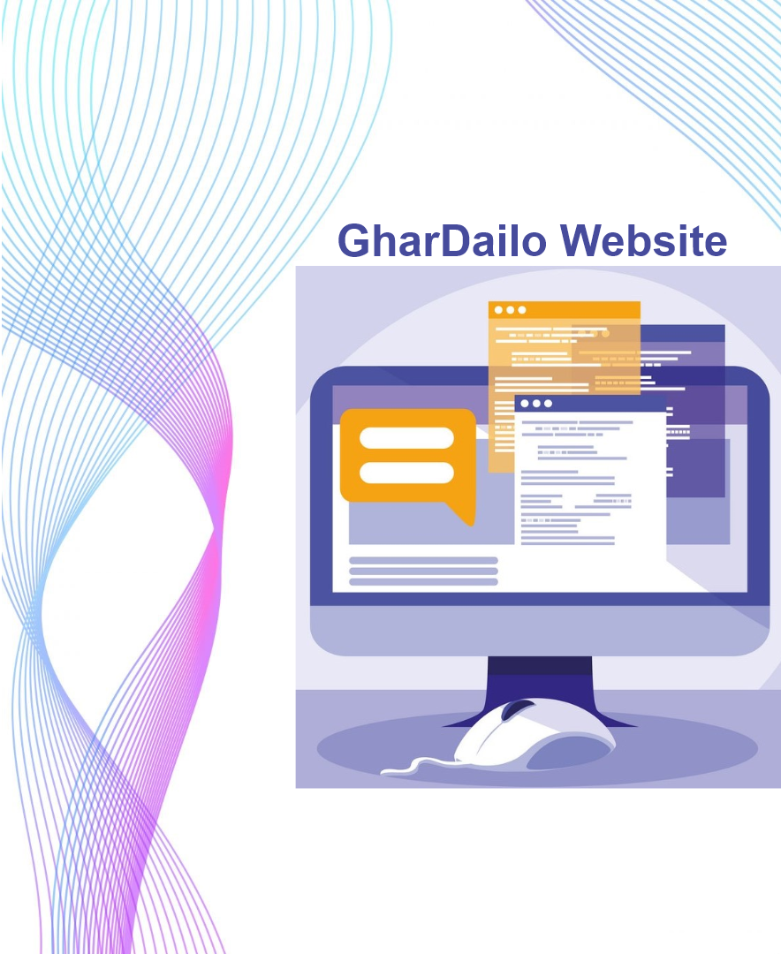

**Submitted To: Submitted By:**

ManojShrestha **CU ID:** 10173183

**College ID:** 190199

**Name:** Gauri Shankar Sharma

In the beginning phase, we did lots of research and brainstorming to make better project plans. After then, we all come to a point and the project goal became “providing home-to-home services that will solve every kind of problem faced by people daily at their homes”. We wanted to be to no.1 service providing company. We wanted people to hire any service at any condition from anywhere, and give reviews to businesses for more flexibility. To complete the project goal, we decided to build a service-providing website with the help of Django, Bootstrap, and other tools and technologies. Before developing it, we also do some research like prototype designing, I made ER diagram for the backend database. We divided the development work between every single of us and my part was to make an admin dashboard, navbar for the website. I did both front-end design and back-end development of my part. I also help my teammates while solving their errors and gave lots of suggestions.

I got to experience teamwork while working on this project which I had no idea before. I learned how to have better and effective collaborations and communications with my teammates. Most importantly, I learned about time management, dividing work, supervising, researching on a particular topic, picturization of ideas, knowledge, and information. I also got to enhance my technical skills too. Learned about Git bash codes and learned to use GitHub Desktop application and Adobe XD. Learned more about Django, HTML, CSS, and JavaScript coding. From the course, I knew about new things like Business Canvas Model, Mission and Vision statement, Ethical Consideration, Pestel Analysis, Stakeholder Analysis, Risk analysis and Issue Log, Mindmap, etc. Implementing and researching these topics for the project practically was more interesting and fun. I learned that just the coding and development process is not enough to complete a project, there are other factors too that are very important and these have a great impact on the success and failure of a project.

I feel that there is more creativity, idea generation, and opportunity to learn faster while completing projects with teamwork. Teamworking helps to build trust, gives better conflict solutions, encourages to take healthy risks, provides better customer service and business results by improving productivity, boosts morality and motivation for employees. We decided to take meetings 2-3 times a week and do the documentation part only after 60% completion of the coding. Some decided to use class-based view methods and some used function-based view methods. We decided to customize the Django user model instead of using its default user model. The website’s navbar design was changed three times so every teammate satisfies with it. There was also a lot of change in the admin dashboard design. Bookmarking business was the feature added during the last period of the project. I always motivate the teammates to complete the project's tasks as soon as possible and then assign the next tasks so that every teammate remains up to date and moves forward at the same level. I also did some documentation after completing my project’s tasks so that this will reduce other teammate's workload too and there will remain enough time for the documentation part. I compromised some of my ideas to support my teammate's ideas which are different from mine and to have healthy conflicts.

At last, we completely build a website as per our requirements. It didn’t match exactly with our visions but it covered almost all of it which takes us to our success. Hiring services, bookmarking businesses, giving reviews and ratings to businesses, and business sending notifications to the customers, adding workers, pictures, services were successfully implemented but assigning a particular worker to a customer's hire, recommending other services to users, service distribution according to places, chatting between business and customer were the things we failed to add in our project.

During the project, I had a difficult time working with different git branches, Django migration, foreign key handling, and didn’t know how to use GitHub desktop and Aasna but my teammate helped me with that. I did not know about the class-based view method, how to customize the Django user model and I got a chance to know about them. I was very good at using CSS, Javascript. I did better web page designs and suggests to teammates better design solutions. I was also good at Django backend coding and no problem occurred with it. I helped some of my teammates too with backend coding. However, I still need to learn more about the Django backend coding to handle and manage lots of Django app, to access data from the databases and present it in the templates, better design solutions, Django customization with user model, and authentication. Next time, I will do deep research on a product from all points of view before designing it to develop a better version of it than the existing ones. I will always make a work dividing and task assigning table to assign tasks to teammates according to their strengths and weakness so that the project development process does not delay and move forward smoothly.

Finally, I am very satisfied with my project because we were successful to build a website that provides services and solves people’s daily problems. This project taught me that working with teammates is always beneficial for enhancing our skills and identifying our weakness areas. It provides a better platform to implement new ideas at a very fast speed. I also learned that the success of a project doesn’t depend only on the activity of the product but other external and environmental factors too that impact the business strategies. From now on, I will be always enthusiastic to work in a team instead of working alone. I will always look after a product of a project from all of the perspectives so that there will remain no factors that can have a bad impact on the business. I am also thinking of creating my team and start a business in the future.